**Computer Architecture Lab Report Week 5**

**Full name: On Quang Tung**

**Student ID: 20226096**

Assignment 1

#Laboratory Exercise 5, Home Assignment 1

.data

test: .asciiz "Hello World"

.text

li $v0, 4

la $a0, test

syscall

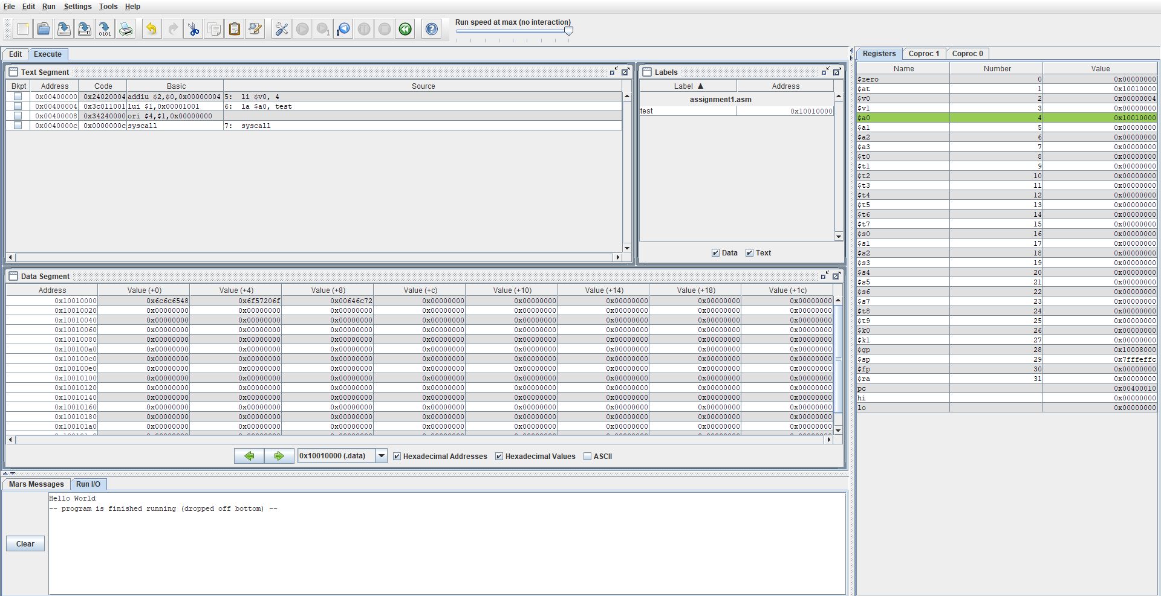

* Chương trình chạy đúng kết quả mong đợi.

Assignment 2

.data

str1: .asciiz "The sum of "

str2: .asciiz " and "

str3: .asciiz " is "

.text

li $s0, 1

li $s1, 2

add $s2, $s0, $s1

#Print s1 = "The sum of "

li $v0, 4

la $a0, str1

syscall

#Print $s0

li $v0, 1

move $a0, $s0

syscall

#Print s2 = " and "

li $v0, 4

la $a0, str2

syscall

#Print $s1

li $v0, 1

move $a0, $s1

syscall

#Print s3 = " is "

li $v0, 4

la $a0, str3

syscall

#Print $s2

li $v0, 1

move $a0, $s2

syscall

Exit: li $v0, 10

syscall

Kết quả chạy:

* Load các giá trị $s0, $s1, và $s2

* In ra “The sum of ”

* In ra $s0

* In ra “ and ”

* In ra $s1

* In ra “ is ”

* In ra $s2 (=3 do $s0 = 1 + $s1 = 2)

Assignment 3

#Laboratory Exercise 5, Home Assignment 2

.data

x: .space 32 # destination string x, empty

y: .asciiz "Hello" # source string y

.text

la $a0, x

la $a1, y

strcpy:

add $s0,$zero,$zero # $s0 = i = 0

L1:

add $t1,$s0,$a1 # $t1 = $s0 + $a1 = i + y[0]

# = address of y[i]

lb $t2,0($t1) # $t2 = value at $t1 = y[i]

add $t3,$s0,$a0 # $t3 = $s0 + $a0 = i + x[0]

# = address of x[i]

sb $t2,0($t3) # x[i]= $t2 = y[i]

beq $t2,$zero,end_of_strcpy # if y[i] == 0, exit

nop

addi $s0,$s0,1 # $s0 = $s0 + 1 <-> i = i + 1

j L1 # next character

nop

end_of_strcpy:

#print x <-> $a0 to check

li $v0, 4

#la $a0, x

syscall

* Chương trình chạy đúng mong đợi với kết quả in ra – x khớp với y

Assignment 4

#Laboratory Exercise 5, Home Assignment 3

.data

string: .space 50

Message1: .asciiz "Nhap xau: "

Message2: .asciiz "Do dai xau la: "

.text

main:

get_string:

#Input string from dialog

li $v0, 54

la $a0, Message1

la $a1, string

la $a2, 50

syscall

get_length:

la $a0,string # $a0 = address(string[0])

add $t0,$zero,$zero # $t0 = i = 0

check_char:

add $t1,$a0,$t0 # $t1 = $a0 + $t0

# = address(string[i])

lb $t2, 0($t1) # $t2 = string[i]

beq $t2, $zero, end_of_str # is null char?

addi $t0, $t0, 1 # $t0 = $t0 + 1 -> i = i + 1

j check_char

end_of_str:

end_of_get_length:

subi $t0, $t0, 1 # $t0 = $t0 -1 -> i = i - 1

print_length:

li $v0, 56

la $a0, Message2

move $a1, $t0

syscall

exit:

li $v0, 10

* Giả sử nhập xâu “tunn” có độ dài là 4 chữ cái

* Message Dialog trả về độ dài của xâu là 4

* Chương trình chạy đúng kết quả mong đợi

Assignment 5

.data

string: .space 20

mess1: .asciiz "Get char number "

mess2: .asciiz ": "

mess3: .asciiz "The reversed string is: "

endline: .asciiz "\n"

.text

li $s0, 0 # i = 0

li $s1, 20 # maximum chars

li $s2, 10 # char "\n"

la $s3, string # address of string[0]

read_char:

beq $s0, $s1, end_read_char # if i = 20, exit

# Print "Get char number "

li $v0, 4

la $a0, mess1

syscall

# Print i

li $v0, 1

addi $t1, $s0, 1

move $a0, $t1

syscall

# Print ": "

li $v0, 4

la $a0, mess2

syscall

# Read char

li $v0, 12 # $v0 is storing the input char

syscall

move $t1, $v0 # move to $t1

beq $v0, $s2, end_read_char # if char = "\n", exit

# Print "\n"

li $v0, 4

la $a0, endline

syscall

# Store char in string[i]

add $t0, $s3, $s0 # $t0 = *string[i] = $s3 + $s0 = *string[0] +i

sb $t1, 0($t0)# store the input char at *string[i]

addi $s0, $s0, 1 # i = i + 1

j read_char

end_read_char:

# Print "The reversed string is: "

li $v0, 4

la $a0, mess3

syscall

# Print string: for(n->0)

print_string:

li $v0, 11

lb $a0, 0($t0)

syscall

beq $t0, $s3, end_print_string

subi $t0, $t0, 1

j print_string

end_print_string:

# Exit

li $v0, 10

syscall

* Giả sử nhập xâu “abcd”, xâu có độ dài < 20, kết quả mong đợi sẽ là “dcba”

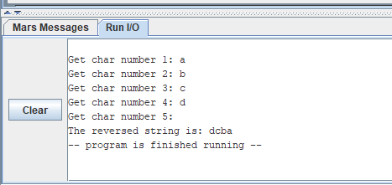

* Chương trình chạy đúng kết quả mong đợi
* Giả sử nhập xâu “abcdefghijklmnopqrst”, xâu có độ dài = 20, kết quả mong đợi sẽ là “tsrqponmlkjihgfedcba”

* Chương trình chạy đúng kết quả mong đợi